**Live Data Agent™**

*Free your IBM OMoC production data to your Business Users*

**Since the release of the IBM Order Management on Cloud (OMoC)** customers have been challenged to access their production data in near-real time and have faced the frustration of having to use the only solution made available by IBM that moved table-level entity data over FTP to CSV flat files on an hourly basis at best. Consuming data in this form is not only error-prone, but cumbersome and makes it extremely difficult to expose that data to their business users who need to glean important insights from that data trapped in their IBM OMoC production system.

### Figure 1 - IBM OMoC Data Extract Agent vs. Live Data Agent

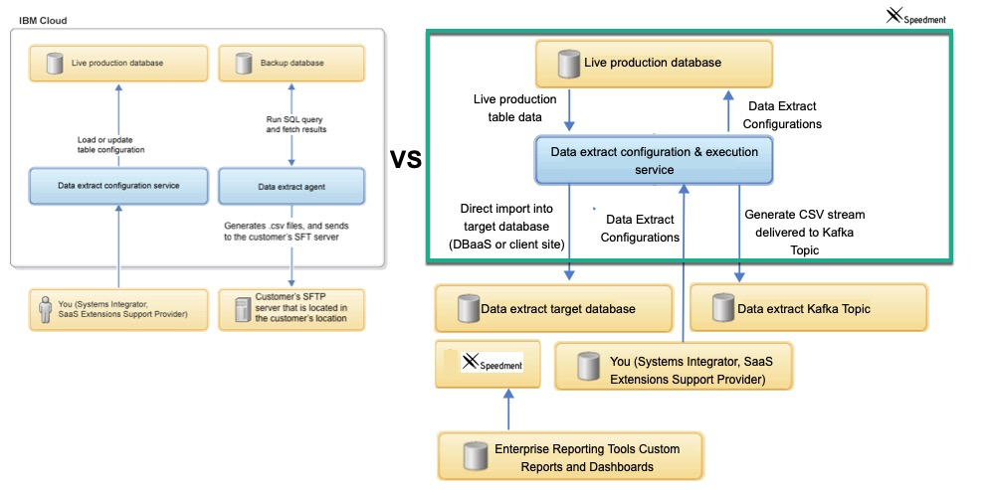

# 1. The Obstacles

In the world of IBM Order Management on Cloud (OMoC), customers are ***not*** granted direct access to their production database via JDBC or any other open standard. This creates a major obstacle for customers looking to use their enterprise reporting tools to connect to their order repository to run reports from in near real time. Although IBM provides an agent for customers that will extract data from select tables, the agent does so by creating FTP files and transferring them to the customer site leaving it up to the customer to convert those files into something their reporting tools can generally use. Furthermore, there is no way to schedule these FTP extracts any more frequently than one hour at a time, which means, at best, the data is more than an hour old, while further, significant efforts are required to to adjust the routines processing the FTP files to adapt to any changes to the data extract configurations. This is just plain difficult and customers often wonder why they can’t have their own data extracted directly into their own shadow copy for use in analytics and reporting and on a near-real time basis. **Well now that’s possible with Live Data Agent for IBM OMoC!**

# 1.1 A Better solution to Access Customer Data

It’s apparent that a better solution is needed for IBM OMoC customers to access their production data in near-real time and the ideal solution would have the following benefits and capabilities.

1. The solution would be a turn-key replacement of the IBM Data Extract Agent that uses cumbersome FTP to transfer table row/column data from the **Backup** IBM OMS system to a remote FTP file system with an agent that moves the data from the **Production** instance over a *Kafka* Topic Queue, directly into a shadow database or both. From a Kafka Topic, it can be easily loaded into a database of the customer’s choosing (DBaaS or On-Site) using a Client-Side Kafka Consumer application (provided with the solution) that can automatically move the data on the Kafka Topic directly into a client-side shadow database. That database, in-turn will be directly accessible to your enterprise reporting tools and by Speedment’s enhanced streaming tools via JDBC and ***all*** it’s capabilities.

1. The solution should utilize all the same configuration tables that are already available to set up the IBM Data Extract Agent. This means customers can use existing IBM API’s to configure what is fed to the Live Data Agent. For the most part, the documentation for that IBM Data Extract agent should still apply, disregarding the FTP-centricity aspects since FTP is not used.. Those docs are here:<https://www.ibm.com/support/knowledgecenter/en/SSGTJF/com.ibm.help.omcloud.administer.doc/tools/c_omc_dataextract.html>

1. The solution should utilize Transactional Kafka technology (Kafka is the latest in Scalable Messaging Technology and is used by IBM internally and by many others) to move the data from the IBM OMoC Production DB to a Kafka Topic. The data is delivered to the queue in Comma Delimited Format and the delivery is very fast, very reliable, and very scalable. Using Kafka Transactions, the clients can request only the committed records from the topic and can communicate to the Kafka Partition which records have been consumed. This virtually eliminates any issues with data loss and ensures only what was intended to be consumed to be consumed.
2. The solution should allow customers to “**Override**” the part of the ***Live Data Agent*** that moves the data to **Kafka** in CSV format, so the customer can instead, decide to move it over their own ESB technology The default implementation of this override moves it over Kafka in CSV format and/or directly into a target database you can configure via **customer_override.properties**.
3. Since the data is typically going to be targeted for a Database vs FTP files, the solution should allow the customer to configure table groups and sequence the extracted tables so they can, for example, send the YFS_ORDER_HEADER records before YFS_ORDER_LINE records which have a one-to-many relationship and leverage foreign keys to tie the headers to the lines. This grouping should not require any change to the existing YFS_DATA_EXTR_CFG table to accomplish this.
4. The solution should come with a Client Side Server application that can move the data from the Kafka Topic to a **target** to a database (DBaaS or Local) via JDBC. That client application should only read the committed records from the Live Data Agent topic and should be stoppable, and restartable, and should allow multiple consumers to be active to support one-to-many target db instances. It should also have the ability to create the corresponding table schema on the destination database using the YFS_DATA_EXTR_CFG configurations stored and to re-create any of these tables as new columns are added or others dropped.
5. The solution should extend IBM’s DataExtract’s “First Run” capabilities that is used to synch back any number of days up to the current date/time. This solution should allow customers to trigger a **Reset** to force any Pending or Running tasks refreshed to a given start date dictated by the table’s **FirsRunExtractInDays** configuration setting. It should also facilitate a way to tell the downstream client what tables, if any, should be deleted, dropped, created, or dropped and created, or left as is in preparation for getting a new full data synch.

# 1.2 Conclusion

The Live Data Agent lays the groundwork for IBM OMoC customers to realize the full potential of their order management data that is today, ***trapped*** inside the four walls of the IBM Cloud data centers. Using this revolutionary Data Extract tool that is purpose built for IBM OMoC using all the standard IBM OM Agent framework, customers can finally get at their critical transaction data, in near real-time, quickly, efficiently, and with little to no impact on their production system. Once the data is extracted into the customer-owned databases, they’re free to leverage the proprietary tools, or any of their other enterprise reporting frameworks to build the real-time reports..

Finally, if you’re an IBM OMoC customer leveraging the IBM Cognos on Cloud solution, you now have a much more flexible alternative that will allow you to use your own internal enterprise reporting tools. Your reports will be more real-time and you can reduce the resources needed to care and feed this less than optimal reporting solution.